Jyanyi Prasad DAV Public School
Holidays homework (2021-2022)

CLASS X

ENGLISH

Project:

- Write different article UBs like- self composed poems, reports on excursion, speech, diary entries, story writing, riddles, puzzles, etc. for School Magazine( any three)

- Reading of a story book or short novel etc. and do write their Book Review properly with the theme and summary, characterization etc.
(C) Assignment:

1. WriteSummary for any Two chapter done in class from the both text book including all the events,

characters in detail

- Letter Writing-(one example for each)

Business Letter- Complaint, Placing Order, Enquiry. Official Letter- Editor, any Office/Department of Govt
- Diary Writing (any one memorable day of Summer Break)

- Article Writing Topic- E -fever"
(G) Grammar: (2 exercise for each)

1. Editing 2.Omission
3. Jumbled Words
Do any 5 sections from 7

कक्षा दसवीं –विषय-हिंदी
ग्रीष्मावकाश कार्य 2021-22

अप्रैल अवम मई में कराया गया सम्पूर्ण कार्य याद करो |
रचना के आधार पर वाक्य भेद की पीपीटी तैयार कीजिए|
a/4 शीट पर शरीर से सम्बंधित मुहावरे लिखिए एवं चित्र भी चिपकाए |
वैक्सीन के बारेमें अपनी राय 100 शब्दों में दीजिये |(अनुच्छेद)
कोरोना के कारण हर व्यक्ति सहमा –सहमा सा है लघु कथा लिखिए |

Subject : Maths
Part - 1
Q1. Revise chapter 1 , 2 , 3 from NCERT book

Part - 2

Q1. Can 2 numbers have 16 as their H.C.F and 380 as their L.C.M ? Give reason. Q2. The H.C.F of two numbers is 16 and their product is 3072 . Find their L.C.M
Q3. What is the smallest number that when divided by 35 , 56 and 91 leaves reminders of 7 in each case.
Q4. A rectangular Courtyard is 18.72 m long and 13.2 m broad . It is to be paved with square tiles of the same size . Find the least possible number of tiles.
Q5. Prove that √5+√3 is irrational .

Q6. Express 429 as the product of its prime factors . Q7. Write the fundamental theorem of arithmetic .
Q8. If 4 is a zero of the cubic polynomial x³-3x²-10x+24 , Find it's other two zeroes .

Q9. What must be subtracted from 8x⁴+14x³-2x²+7x-8 , so that the resulting is exactly divisible by 4x²+3x-2.
Q10. What must be added to 4x⁴+2x³-2x²+x-1 , so that the resulting is divisible by x²+2x-3. Q11. Find all the zeroes of x⁴+x³-34x²-4x+120 , If two of its zeroes are 2 and -2 .
Q12. Find the value of a and b for which of the equation has infinitely many solutions 2x+3y = 7
2ax+ay = 28 - by

Q13. The sum of two numbers is 8 . If their sum is 4 times their difference , find the numbers .

Q14. Two numbers are in the ratio 5 : 6 . If 8 is subtract from each of the numbers , the ratio becomes 4 : 5 . Find the numbers .

Q15. The age of father is twice the sum of the ages of his two children. After 20 years , his age will be equal to the sum of the ages of his children . Find the age of the father .
Part 3 (Lab activity )

To find the H.C.F of 2 numbers experimentally based on Euclid's division lemma on chart .

Physics
A.Solve these questions in your notebook 📓.
1.Two electric circuits I and II are shown below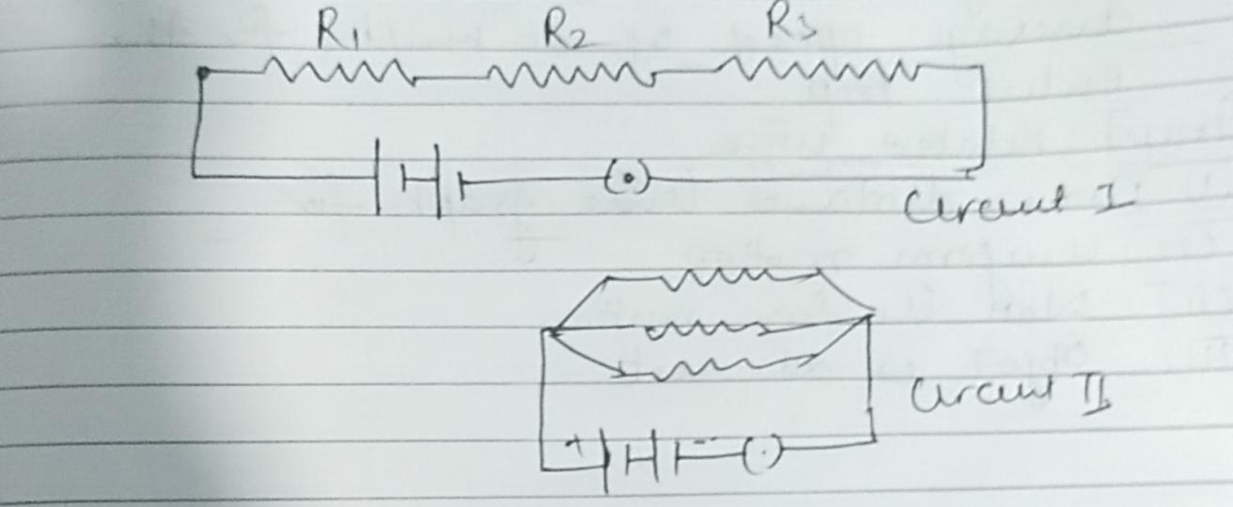
i) Which of the two circuits has more resistance and Why?
ii) Innehich circuit the potential difference across resistors is equal and in which circuit current across all resistors remains same.
iii) Find the value of current I in the circuit given below.
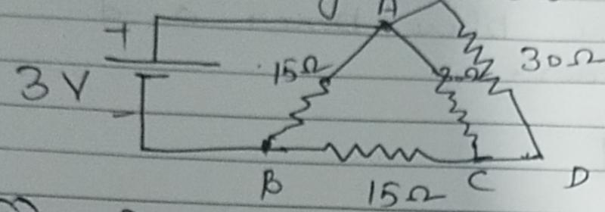
2. Find the equivalent resistance across following circuit.
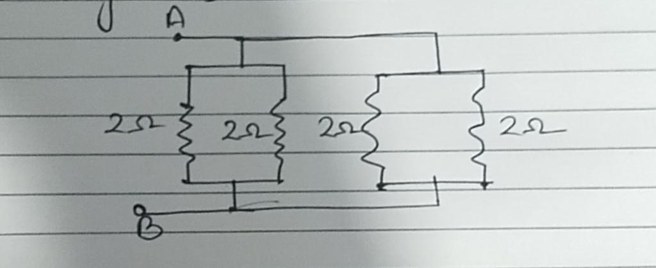
3. Find out the following in the electric circuit given in the figure.
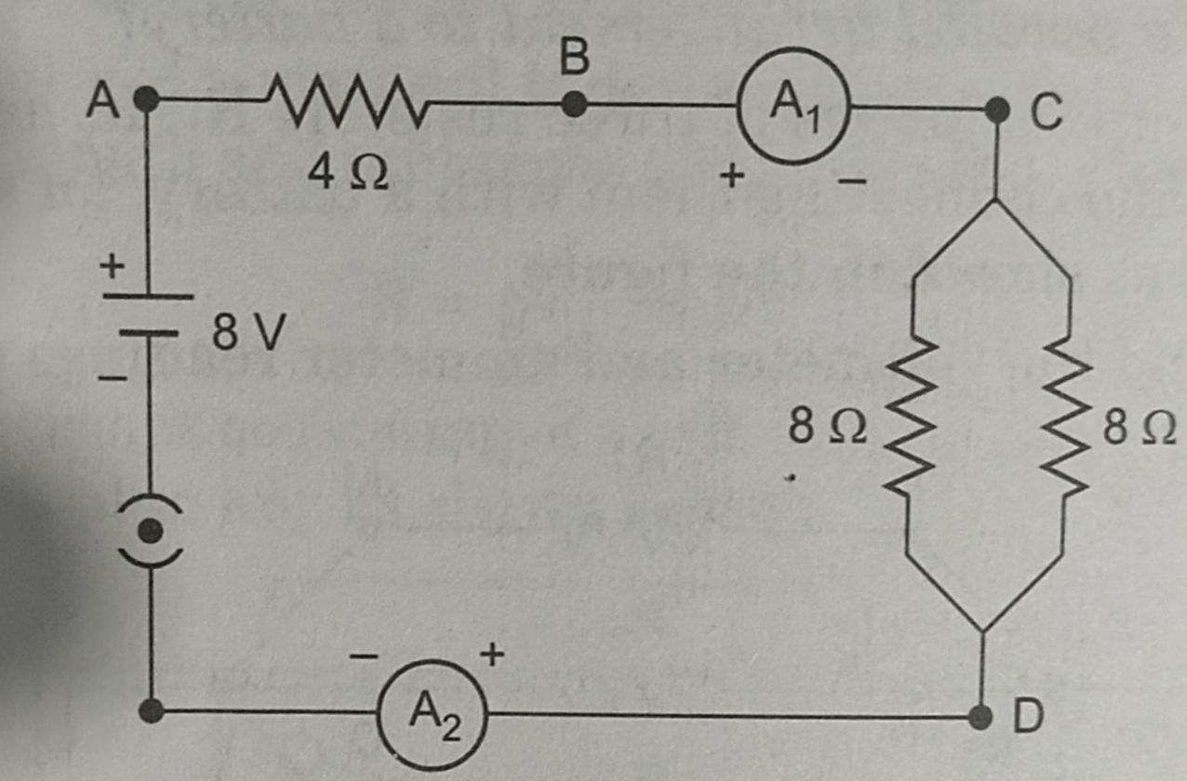
a. Effective resistance of two 8 ohm in the combination.
b. Current flowing through 4ohm resistor.
c. Potential difference across 4 ohm resistor
d. Difference in ammeter readings,if any .
4. 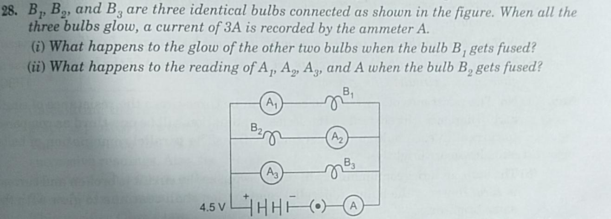
5. Aluminum wire has radius 0.25mm and 75m. If the resistance of the wire is 10 ohm. Calculate the resistivity of aluminum.
ART INTEGRATED ACTIVITY
1. Demonstrate advantages of parallel connection and disadvantages of series connection by using five LEDs, battery and other useful items.
2. Make wall hangings for different symbols and units used in chapter ELECTRICITY 🔌.
REVISE ALL THE BLUE BOXES AND NCERT QUESTIONS OF CHAPTER 12 ELECTRICITY.

Biology
TOPIC: LIFE PROCESSES

Q1. | Why do herbivores have longer, small intestine than carnivores? | (1 marks)
Q2. | Write the balanced chemical equation for the process of photosynthesis. How photosynthesis occurs in desert plants? | (1 mark)
Q3. | In single celled organisms diffusion is sufficient to meet all their requirements
 | of food, exchange of gases or removal of wastes but it is not in case of  multicellular organisms. Explain the reason for this difference. | (2 marks)
Q4. | Draw a neat labeled diagram of human alimentary canal. | (2 marks)
Q5. | Explain the process of nutrition in Amoeba. | (2 marks)
Q6. | How do guard cells regulate the opening and closing of the stomata? | (2 marks)
Q7. | Explain exchange of gases in humans. | (3 marks)
Q8. | State the role of the following in human digestive system: | (3 marks)
- Digestive enzymes
- Hydrochloric acid (Hcl)
- Villi

Q9. Draw a diagram of human respiratory system and label the following: (3marks)
- Part where air is filtered by fine hairs and mucus
- Part which terminates in balloon like structures
- Part which separates chest cavity from abdominal cavity
- Part where exchange of gases takes place.

Q10. Draw a neat labeled diagram of opened and closed stomata. (3marks)
Q11. Draw a neat labeled diagram of human heart by using art integration . (3marks)

( social science)
- Prepare a assignment on DISASTER MANAGEMENT in which type of disaster. Prevention and what we do after the disaster with explains each and every disaster with pics.
- 2. Learn the syllabus done in online classes till now.
- 3. Prepare a project on consumer awareness.
- 4. Prepare a project on sustainable development.

Class – X ( Information Technology)
(Subject Code:402)

- Learn and Complete all that has been taught till now
Chapter 1. Communication Skills – II
Chapter 2. Self – Management Skills – II
Chapter 3. Basic ICT Skills – II
Project Work
- Activity : Check the name of the Antivirus software installed in your computer/Laptop. Scan the drive to Check for Virus. Write a note on your VIT Fair notebook .
- Project Work from Chapter 3 – Operating System and its major , Window 7 and its Desktop
Files and Folders, Threats that affect a computer system
Utility Tools of windows (Disk Cleanup, Disk Defragmenter, Antivirus Software
How to use an antivirus Software
(Note : It must be for every student to prepare a Project file / Student Portfolio)
- Make a PowerPoint Presentation on the topic :-
Basic ICT Skills – II

