JYANTI PRASAD DAV PUBLIC SCHOOL
GARHI JHANJHARA ROAD, GANAUR

CLASS-XIIth (Commerce)

Nothing is more powerful for your future than being a gatherer of good ideas and information. That's called doing your homework.
Jim Rohn

While doing your homework keep remembering Thomas A. Edison
When he says
Genius is one percent inspiration and ninety-nine percent perspiration. As a result, a genius is often a talented person who has simply done all of his homework.

Dear parents,
We wish you a very happy and fruitful time with your children. Summer vacation is the most awaited time for students as they want to play, enjoy and relish with their friends, neighbours and relatives. This is a time for them to stay away from the mundane schedule of daily life. They want to enjoy it in leaps and bounds. But we request you to keep their energy channelised. You should be a part of their enjoyment but time and again a check is required. Now it's your responsibility to make them stay connected with their studies along with fun and frolic & encourage them to do their homework in a neat and tidy manner.

Here are some of the suggested activities that you can do as a family:
1. Prepare a well-being plan for self.
2. Stick to routines or starting new ones.
3. Get up and go to sleep at regular times.
4. Help them explore new hobbies and interest.
5. Read, solve puzzles, play board games, etc.
6. Keep a gratitude journal. Writing down three things you are grateful for every day. Congratulate yourself and others on having a "MEGA DAY".
7. Take out time for Reading, Music, Dance, Singing, and Laughing.
8. Set Challenges- Encourage each other to take up new activities and complete them.
9. Be Creative with Space- Find a corner in the house and allow yourself and your children to decorate it.
10. Involve your children in household activities also..
11. Take them for outing to place of their interest & let them explore the world.
12. Communicate with your children and let them know you fully.
As parents you are requested to keep a watchful eye on your children and stop them from engaging in :
Be Safe
1. Excessive use of mobile phones.
2. playing online games
3. spending a lot of time alone away from family members.

Business Studies

- Revise NCERT questions and Case Studies of chapters 1 to 2 and chapter 11( Marketing Management).
- Prepare a project on any one topic from the following:
- Principles of Management
- Marketing Management
Note: 1. Project file should consist minimum of 25 pages.
2. Use appropriate file and pages for the given project

Accountancy
- Do Additional exercise questions of
Chapter 1 ( starting page no. 1.140) : Question No. 80, 90, 98, 100, 102, 111, 112, 116, 118
Chapter 2 ( starting from page no. 2.81) : 46, 48, 49, 51, 57, 60, 61, 62, 63, 65
Chapter 3( starting from page no. 3.179): 92, 96, 98, 99, 101, 103, 113, 115, 116, 117, 119, 120, 126, 131, 133.
- Prepare project of Accountancy:
a)Comprehensive
b)Specific
Note: Students are required to prepare a Comprehensive Project only.
Steps for Comprehensive project:
- Take financial transactions of any reputed Business for a year ( including GST transactions)
- Prepare Journal Entries
- Prepare Ledger Accounts
- Prepare Trial Balance
- Prepare profit and loss Account and Balance Sheet.
- Calculate different Ratios by using data from the profit and loss Accounts and Balance Sheet
- Draw conclusions on the basis of Ratios and write comments.
3. Prepare any Art Integration Activity. Some examples are there in your Class Group.

Economics

- Prepare 20 objective-type questions with answers to chapters 1,2,3,4 of Macro Economics and chapter 1 & 2 of Indian Economic Development.
- Work these out in a separate notebook:
- Compare the map of British India with that of independent India and find out the areas that become part of Pakistan. Why were those parts so crucial to India
From an economic point of view.
- How many iron and steel industries are there in India at present? Are these iron and steel factories the best in the world? Or do you think these factories need restructuring
And upgradation? Write down your view.
- Solve all the unsolved numerals based on national income given at the back exercise
Of chapters 3 &4.
- Give a brief description of ‘Trade through SUEZ CANAL’.

Mathematics
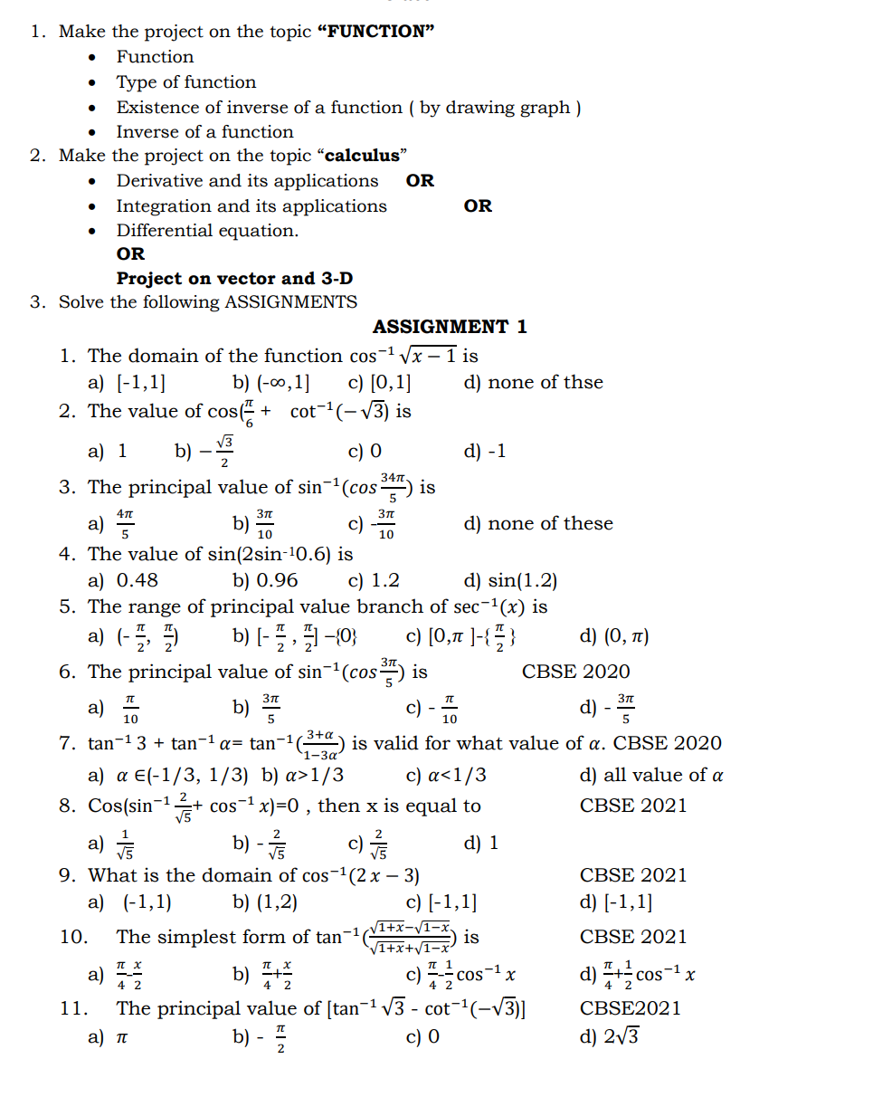
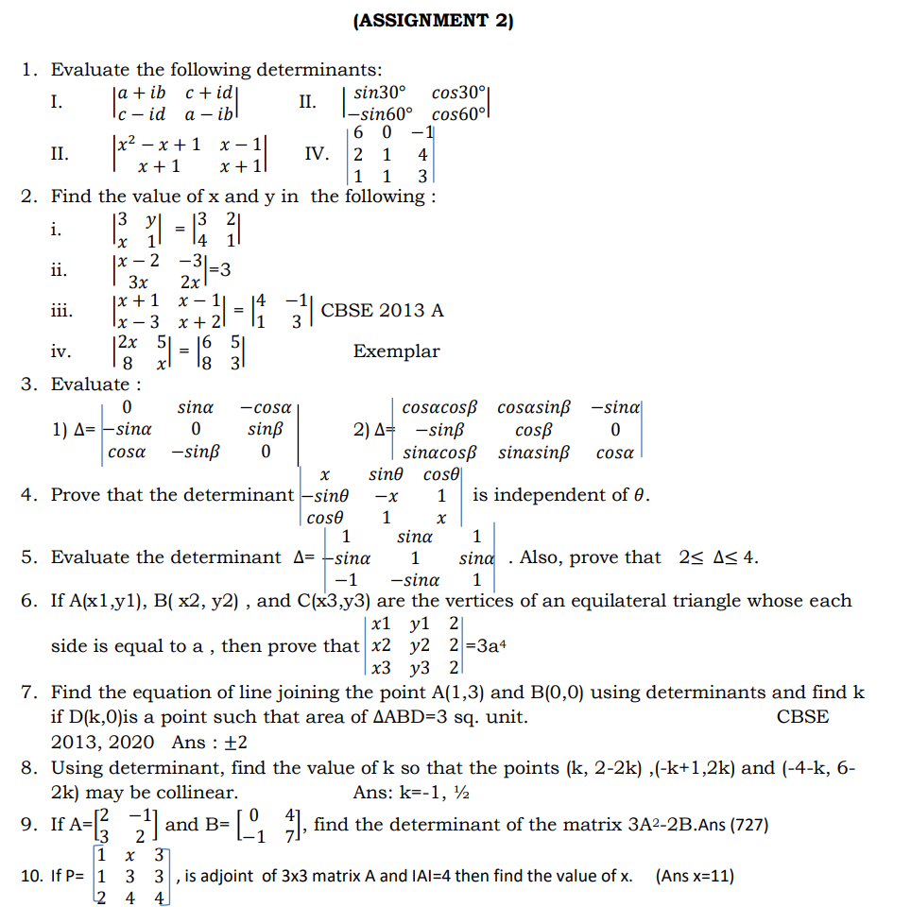

Chapter 5
Differentiate the following :
- If f(x)=IcosxI, find f’($\frac{π}{4}$) and f’($\frac{3π}{4}$). NCERT EXAMPLAR
- If f(x)=I cosx-sinx I, find f’($\frac{π}{6}$) and f’($\frac{π}{3}$). NCERT EXAMPLAR
- If f(x)= I logx I, x$>0$, find f’(1/e) and f’(e). NCERT EXAMPLAR
Differentiate the following w.r.t x :(4-6)
- F(x)= $e^{\sqrt{tanx}}$
- Y=log( secx + tanx ) , Y= log( x+ $\sqrt{a^{2}+x^{2}}$) NCERT EXEMPLAR( CBSE 2003)
- If y=( x+ $\sqrt{a^{2}+x^{2}}$)^{n} , then prove that $\frac{dy}{dx}$= $\frac{ny}{\sqrt{a^{2}+x^{2}}}$
- If f(x)=$\sqrt{1+x^{2}}$, g(x)=$\frac{x+1}{x^{2}+1}$ and h(x)=2x-3, find f’(h’(g’(x))). CBSE 2015
- If y=$\sqrt{\frac{1-x}{1+x}}$ , then prove that (1-x²)$\frac{dy}{dx}$ + y=0.
- Differentiate log₇(logx) w.r.t.x
- Differentiate log$\sqrt{\frac{1+cosx}{1-cosx}}$ w.r.t x
- Differentiate sin^{m}xcos^{n}x.
- If y=$x^{e^{-x^{2}}}$ then find $\frac{dy}{dx}$. CBSE 2015
- Differentiate the following function w.r.t. x
- $\{\sqrt{\frac{1-cosx}{1+cosx}}$ } - $π$<x< $π$. NCERT EXAMPLAR
- $(secx+tanx)$ ,- $π/2$<x< $π/2$, NCERT EXAMPLAR
- $\{\frac{\sqrt{1+sinx }+\sqrt{1-sinx}}{\sqrt{1+sinx}-\sqrt{1-sinx}}$}
- $\{\frac{a cosx-b sinx}{b cosx+a sinx}$ }, - $π/2$<x< $π/2$.
- $\{\frac{\sqrt{1+x^{2} }+\sqrt{1-x^{2}}}{\sqrt{1+x^{2}}-\sqrt{1-x^{2}}}$}, -1<x<1 , x$≠$0 CBSE 2015
- Y=$(x\sqrt{1-x}$ - $√x\sqrt{1-x^{2}}$) CBSE 2010
- Y=$(\frac{1+cosx}{sinx}$) CBSE 2018
- Y=$(\frac{cosx+sinx}{√2}$), - $π/4$<x< $π/4$.
- If y=$(6x \sqrt{1-9x^{2}}$), $\frac{-1}{3√2}$<x< $\frac{1}{3√2}$ CBSE 2017
- Differentiate $\{\frac{2^{x+1}.3^{x}}{1+{(36)}^{x}}$) w.r.t. x cbse 2013

English
1.Read the following carefully and make a question bank containing at least 75 questions to be used in 'Interclass Quiz Competition'.
Flamingo:
Lesson 1- The Last Lesson
Lesson 2- Lost Spring
Poem1- My Mother at Sixty Six
Vistas:
Lesson 1- The Third Level
Lesson 2- The Tiger King
2. Write a Debate on the topic 'The indifferent Nature of India in Ukrainian and Russian War is Justified'. Suggest some measures on how to escape from this.
3. Write an article on the topic 'Nature has Become Revengeful' in 150-200.
4. Make a catchy project on any one of the following according to the roll numbers mentioned:
a. Indian Mythology: Exploring the rich tradition of Indian mythology and its significance in Indian culture and society. ( Roll No. 1-7)
b. Social Media: Fifth Pillar of Society
( Roll No. 8-14)
c. Cyber Crime: Types, Ways to escape and laws against it( Roll No. 15-21)
d. Moral Degradation in Indian Youth: Reason, consequences,ways to check etc.( Roll No. 22-28)
e. Juvenile Delinquency ( Roll No. 29-34)
5. You are going to celebrate the 50th marriage anniversary of your grandparents. You want to arrange a grand function. Draft an invitation for the same. (Use drawing sheet only)

Note: Questions 1- 3 are to be done
in fair notebook.
Question 3 is to be done on a drawing sheet.
Question 5 is to be done on A4 assignment sheets.(Use good quality of Assignment sheets and file.)

Physical Education
1.Write and Learn MCQs of Unit - 1 to 4 in a separate note - book.
2. Project on Khelo India test. (BPFT)

